Getting Started with DSC

Objectives:
- Create DSC configurations to define the desired state of a system component.
- Apply DSC configurations to ensure that a system complies with the desired state.

Instructions:
Task 1: Creating a DSC Configuration
Open a PowerShell command-line window on your computer. Create a new DSC configuration script that defines the desired state of a system component. For this exercise, we will create a DSC configuration to manage a folder and its contents. Use the following dummy DSC configuration as an example:
Configuration SampleDSCConfig
{
Node localhost
{
File SampleFile
{
Ensure = "Present"
DestinationPath = "C:\DSCDemo\SampleFile.txt"
Contents = "This is a dummy file created by DSC."
}
}
}

SampleDSCConfig -OutputPath 'C:\DSCDemo' -Verbose

To Dos - 1:
- Save the DSC configuration script to a file with a .ps1 extension.
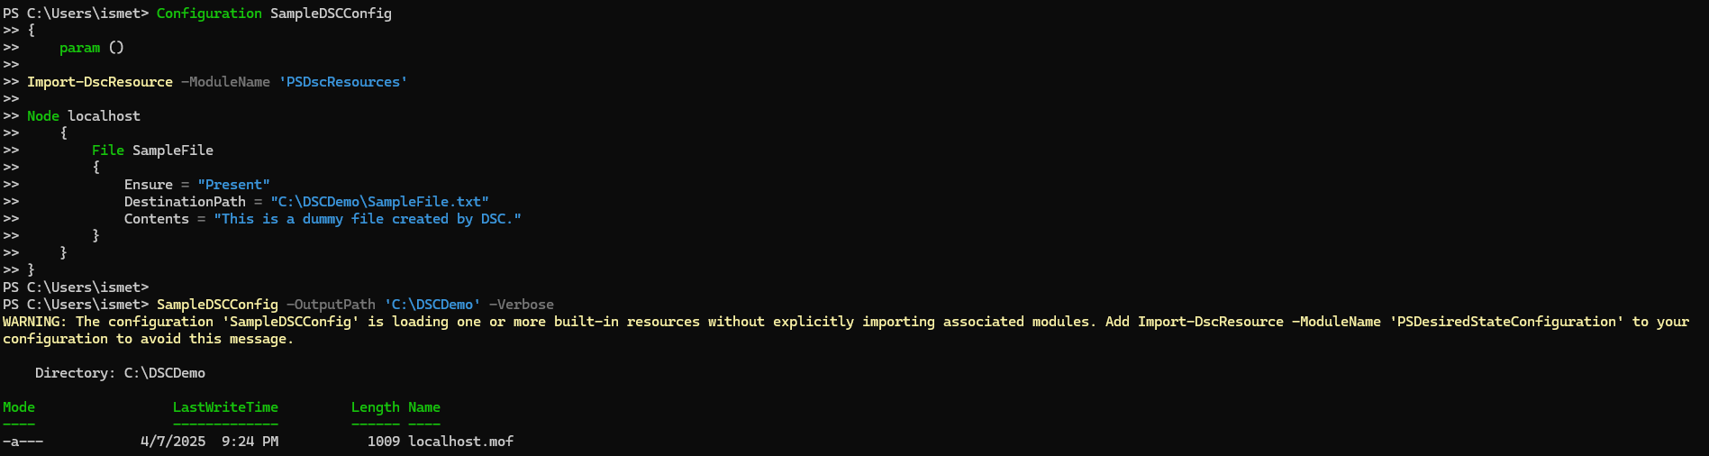

Task 2: Applying a DSC Configuration
Write a PowerShell script that applies the DSC configuration created in Task 1. This script will ensure that the specified file and its contents are in the desired state on your system.
Start-DscConfiguration -Path 'C:\DSCDemo' -Wait -Force -Verbose

To Dos - 2:
- Ensure that you run this script with appropriate permissions to make configuration changes.

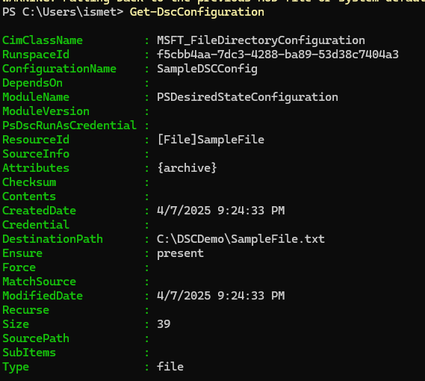
Task 3: Verifying the Configuration
Write a PowerShell script that verifies the current configuration status of the system. Use the Get-DscConfiguration cmdlet to retrieve information about the applied DSC configuration.
Get-DscConfiguration

To Dos - 3:
- Run this script. It will display information about the configuration and its status on your system.
